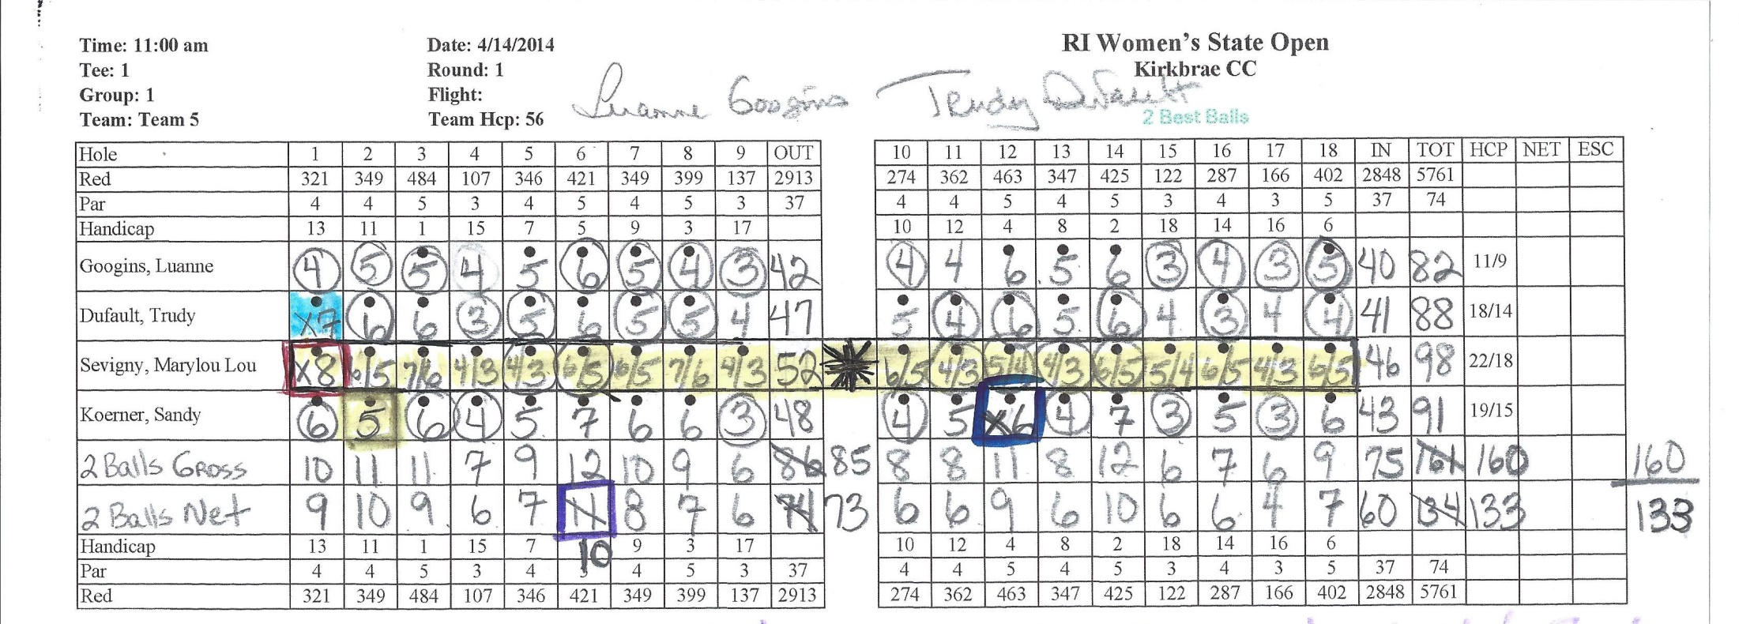
Format-4 person team-2 best balls. These individual tournament scores will be posted by the OSWGA Handicap Chair.
The team has circled the 2 best balls they have chosen for each hole. Then they brought down the total gross score to the gross line. Deducting strokes when applicable they have entered the total net score in the net box. You must circle the 2 balls used or the scoring committee will use the 2 highest scores. Note that on the 2nd hole, they circled 2 sixes when one player had a five. The scoring committee cannot change this. We don’t know what happened out there so although the 5 is lower than one of the sixes, it stands. However, on hole # 6, they circled 2 scores, brought down the gross and then the net. They should have deducted 2 strokes and only deducted 1. This can be changed. Note on hole #1 Trudy took an X7. She picked up before reaching the green so recorded an X and her max. On hole # 12, Sandy was lying 5 and a short putt from holing out but 2 others had holed out for a 6. Sandy picked up and took her most likely score-5 plus 1 putt for an X6, NOT her max of 7. Please, please, please, we beg of you, do not SLASH like the scores are slashed for Marylou. (6/5). Only enter the gross score in the box for each player for each hole as shown with the other 3 players. We’re sure you’ll agree, it’s easier to read!
At the end of the round, kindly add individual scores(OSWGA will post) as well as the gross and net for the team for this tournament, have 2 in your group sign and attest the card. This team had some addition errors but there is no penalty for addition errors. Your attention to detail with the math is appreciated. Feel free to use your smart phone calculator app AFTER play. Each group should keep 2 cards throughout the round and check at the end to be sure they get the same results. Thanks for your help and thanks in advance for picking the person who writes the most legibly to do the scoring. FYI-Players and scores on sample cards are picked randomly and intended for demonstration purposes only. Any questions-please ask.

