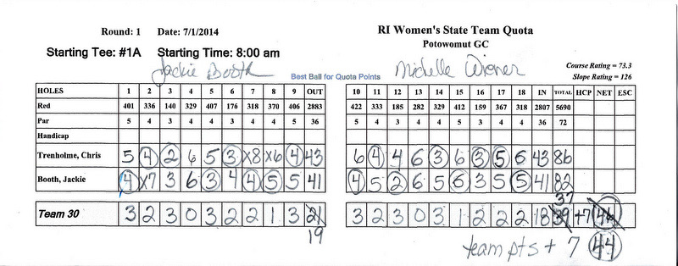
Potowomut-RI Women’s State Team Quota- Note on the scorecard the Team’s starting points are noted on the card.(7) The team has recorded a score for both players as this score will be posted by OSWGA. Note that on the 2nd hole, Jackie picked up as her partner was in for 4. Jackie had hit a ball OB, was lying 7 before reaching the green. She picked up as there are no points for a double bogey & over. Note she recorded her max of 7 preceded by an X-an X should precede a score every time a player picks up. Similar situation for Chris on hole # 7 with Chris recording her max of 8. On hole # 8, Chris was putting for 6 from a foot away-so she recorded her most likely score-a 6 NOT her max of 8-again preceded by an X. There are no points for double bogey and higher-please pick up if you are out of the hole!
The team has chosen the lowest score per hole, CIRCLED IT and then applied quota points in the box below to a score less than a double bogey using the formula as follows: Points are as follows on gross scores: 2 or more over par - Double bogey - no points;1 over par - Bogey - 1 pt; Par - 2 pts; Birdie- 3 pts; Eagle - 4 pts; Double Eagle or Hole in one 5- pts; Note they circled the score to use and put the quota points in the box below. Note they made a math error in adding their quota points-no penalty-the scoring committee has corrected the error all the way across. Note the team added their individual scores, their quota points and then added their team starting quota points of 7 at the end for a total of 44 quota points(with the correction). A player and a competitor in the group have both signed the card. We realize your opponents are keeping your scorecard but it is YOUR responsibility to take the time to be sure scores are correct and circled and quota points are applied correctly. Any questions-please ask the scoring committee before turning in your card. Have fun & Good Luck!

